Handbook for Students of the Faculty of Arts
How to Navigate the Faculty and
Find Support for Your Needs

Arts Committee of Assessors, (ACA)
Groningen, 01/09/2023
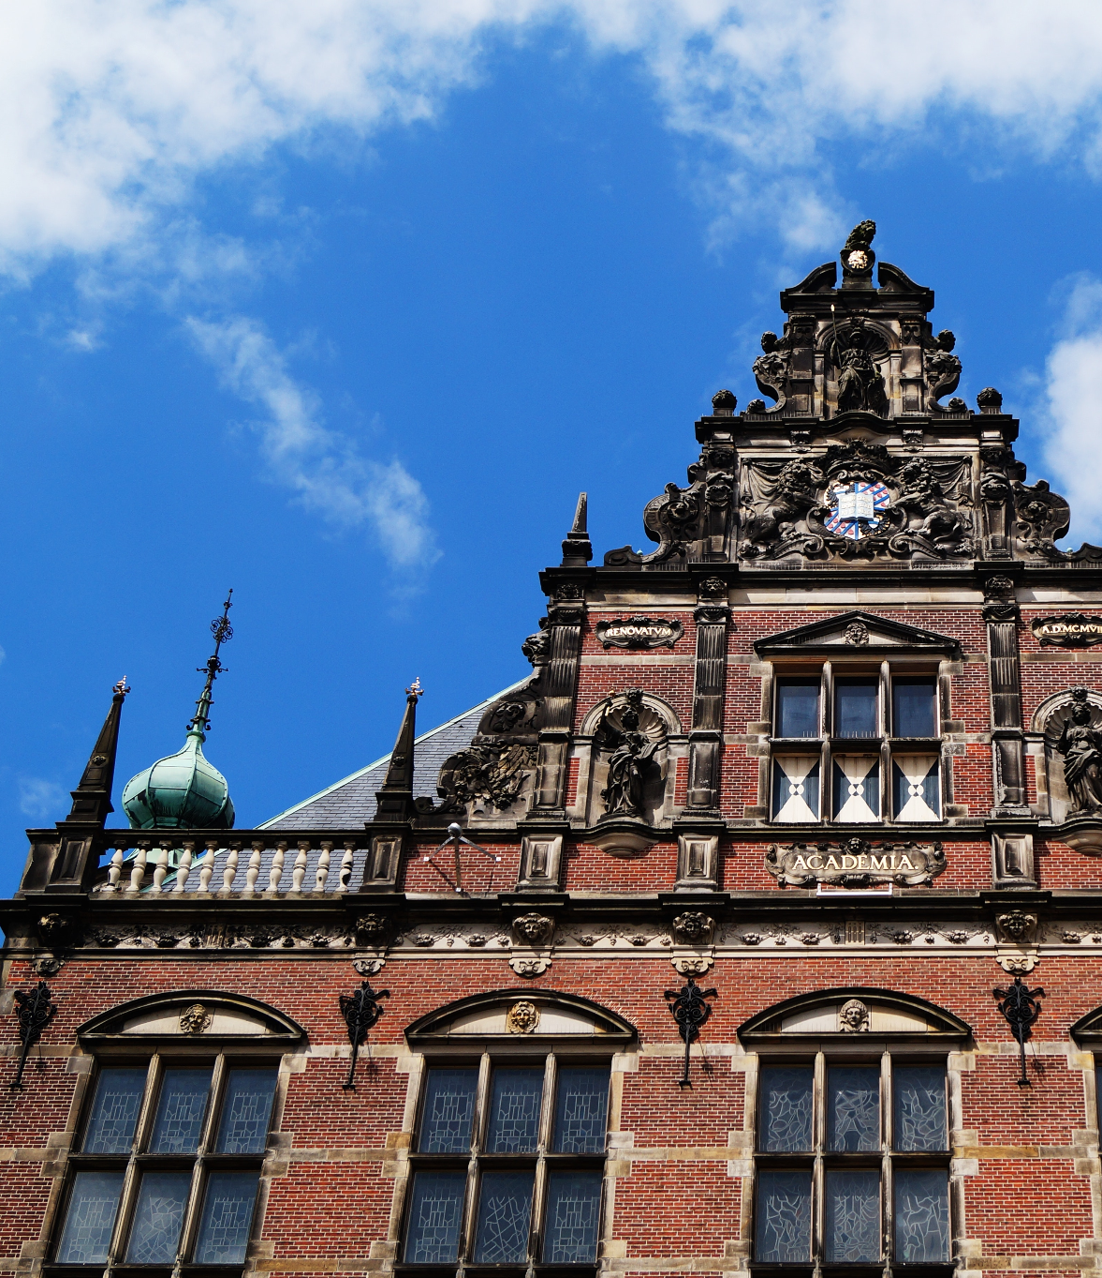
University of Groningen,
Faculty of Arts
Oude Kijk in 't Jatstraat 26
9712 EK Groningen
The Netherlands
Arts Committee of Assessors
artscommitteeofassessors@rug.nl
Date
September 1, 2023.
Foreword
Dear (prospective) students,

This handbook has been created by students for the students with the purpose of aiding you through the organizational aspect of the Faculty of Arts. The first section sets out the outline of all the boards and committees that comprised the Faculty, as well as indicating the role of students and student representatives within it. The second section is meant to illustrate the essential information on the various offices within the Faculty of Arts, which provides students with assistance during their academic years as well as the rules and regulations of the Faculty.

Kind regards,

The Arts Committee of Assessors & The Arts Committee of Assessors
Academic Year 2022/23 Academic Year 2023/24

Carla Goltings - (Cluster 1) Margreet Hoek - (Cluster 1)
Francis (Francesca) Urciullo - (Cluster 2) Lana Fahham - (Cluster 2)
Riemmelth Ruitenbeek - (Cluster 3) Serena Isabella Golfetto - (Cluster 3)
Ylva Axelsson - (Cluster 4) Bram de Kam - (Cluster 4)

Maartje Westenberg - (Faculty Board) Fieke Overmaat - (Faculty Board)
Table of Contents
Programme 3
Mentors 3
Study advisors 3
Programme Committees (PCs, or OCs in Dutch) 3
Cluster Boards 4
Student Assessors 5
Cluster Advisory Committees 5
Structure of the Faculty of Arts 6
Faculty Board 6
Faculty Student Assessor 6
Faculty Consultative Body Education Policy (FOO) 6
Advisory Boards 6
Board of Examiners 6
Admission Committee 7
The Institute of Education (OWI) and Director of Education 7
Student Bodies 8
Arts Committee of Assessors 8
Faculty Council 8
Study Associations 9
List of Study Associations by Cluster 10
Diversity & Inclusion Office 11
Advisory Boards 11
Projects 11
Advisory Committee for Students with a Performance Disability 11
Aletta Jacobs chairs 11
Centre for Gender Studies 11
Graduation Fund 12
Participation Act 12
Pre-University Academy 12
Student Service Center 13
Confidential advisor 13
Portal for Dissatisfaction, Problems, and Complaints 13
Social Safety 14
Social Safety Campaign 14
Zero Tolerance Policy 14
Code of Conduct 14
Teaching and Examination Regulations 15
Student Charter 15

Student Position in the Organization
The Chapter deals with the student position within the various organizations at the Faculty of Arts. It will address the positions from the lowest to the highest levels of the organizations. It also provides a comprehensive guide on the function and composition of the various bodies within the Faculty of Arts.

Programme
The Faculty of Arts offers 16 Bachelor’s programmes and over 50 Master’s tracks. During your time at the University of Groningen, your study programme will likely be part of the Faculty that you have the most contact with. Each programme has a variety of representatives and bodies that you can reach out to. Depending on your question or concern, you can approach one (or several) of these. Unsure of which one to get in touch with? You can find a short summary of each function below - and if one of them is unable to help you, they can direct you to someone who can.

Mentors
In most study programmes, Bachelor’s students are assigned a mentor at the start of their first year. Your mentor will be a staff member connected to your study. If you are struggling with academic matters, such as a specific course, they are there to provide advice and support. Mentors can be reached via email or during their office hours, which you can find information about on the university website.
For more practical (and informal) questions, you can contact your student mentor(s). These experienced students will likely have more insight into the structure of your programme. For example, if you are unsure of who to reach out to with a specific concern, they will likely be able to assist you. Student mentors are often connected to the study association(s) of your programme, which is another forum for receiving support from your fellow students.

Study advisors
The study advisor(s) of your study programme has a comprehensive understanding of the degree as a whole. They can advise you on a wide range of topics, from specific courses to possibilities for further study after you graduate. If there are circumstances that affect your study, they are there to support you. They can inform you about and assist you through the various regulations at the Faculty and University, such as the Binding Study Advice. The study advisors can also refer you to other bodies, such as the Student Service Centre. There is a list containing the study advisors for the Faculty of Arts and their contact information under the ‘Study Info’ tab on Brightspace.

Programme Committees (PCs, or OCs in Dutch)
Each programme at the Faculty of Arts is represented by a Programme Committee, composed of both staff and student members. The goal of these PCs is to improve and guarantee the quality of the programme(s) they represent. They also analyze and approve changes to the Teaching and Examination Regulations (TER/OER). As your representatives, the (student) members receive and ask for feedback to bring to the PC meetings. They address programme-related issues, as well as course-related complaints. You can find the PC members of your programme and their contact details on Brightspace, on your specific programme page under the ‘Study Info’ tab.

Cluster Boards
The Faculty of Arts has five different clusters, every cluster contains Bachelor’s and Master's programs that are related through research and/or education. Each Cluster has its own Board which is responsible for the practical implementation of the education programmes. They are seen as experts on the content of the programmes and make decisions on the organization and staffing of the different departments covered by the Cluster. Their main task is to coordinate the different teaching modules and ensure the programmes’ best possible implementation.
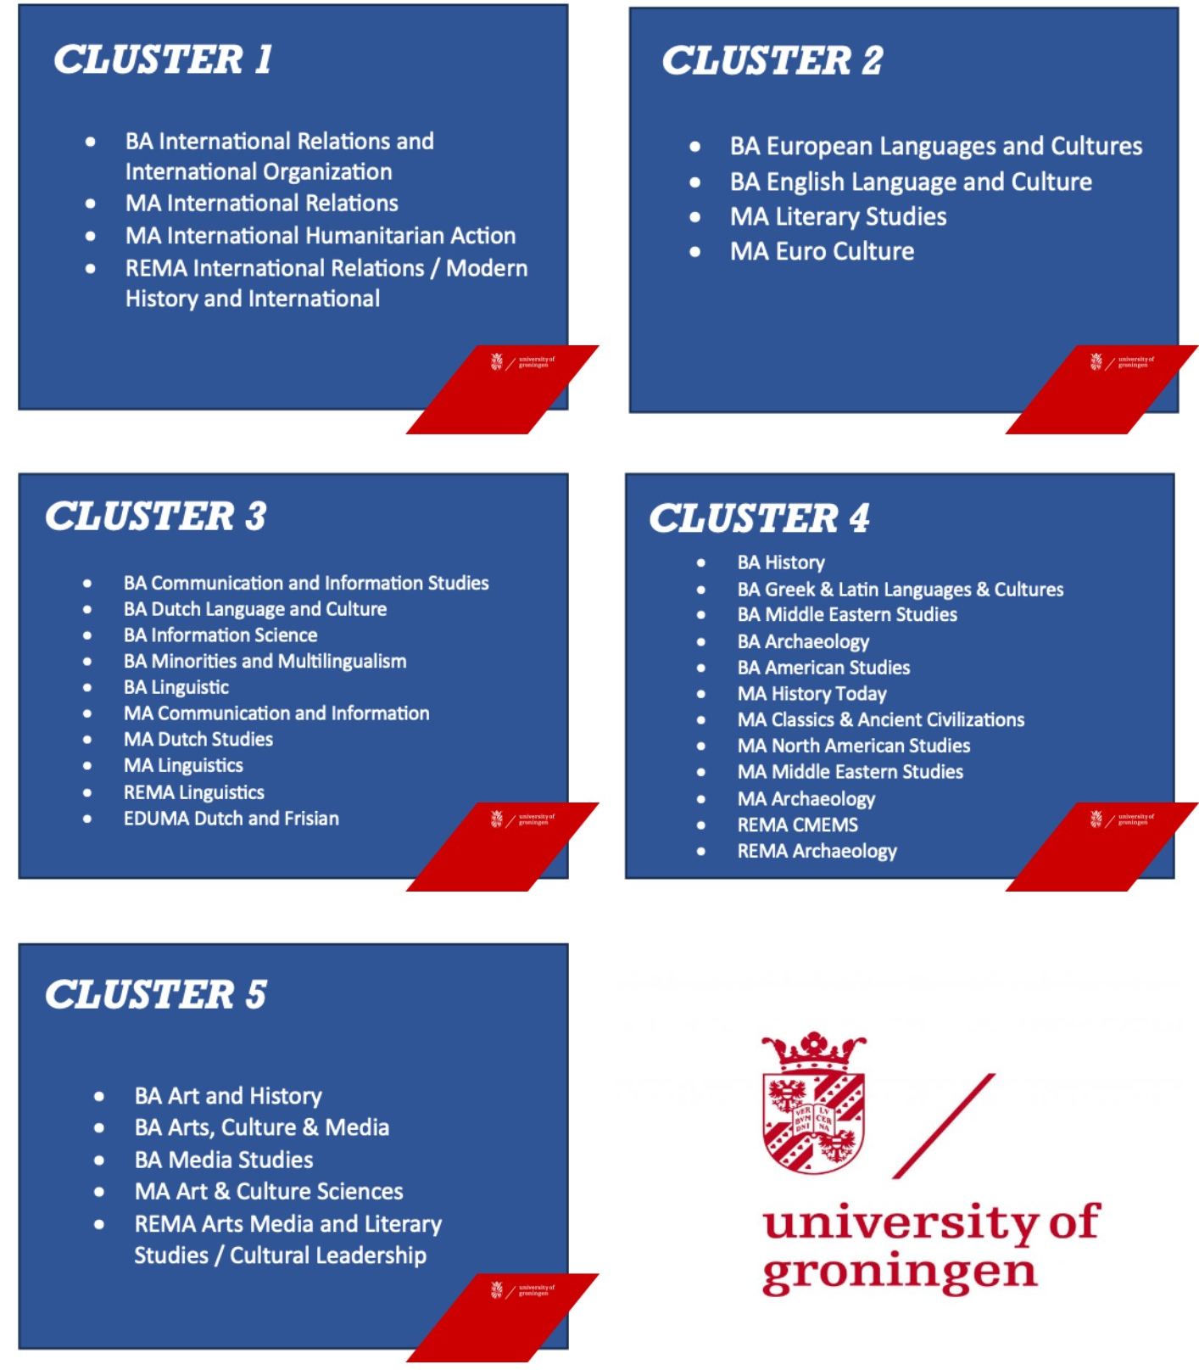
By having the Cluster Board, the Faculty Board can implement policy and changes tailor-made to the different programs and the different programs can stand together stronger when needed. Every Cluster Board consists of several board members, who are staff members of the Cluster, and a Student Assessor. In addition to this, the Cluster Board is also composed of a Cluster Coordinator and HR representative, who are external advisors to the CB and represent the Education Institute.

The Cluster Board, among others, decides on the following matters:
- Programme changes proposed by the Programme Coordinators. They usually ask for the PC's advice and must ask for the PC's permission if the changes mean a difference in the Teaching and Examination Regulations.
- Handles structural complaints about programmes
- Manages hours and finances
- Structural developments within the department

Student Assessors
One student is a member of the Cluster Board. They are enrolled in a programme of the respective cluster and represent the student perspective on the board. The Student Assessor maintains contact with student bodies within their Cluster and cooperates with the student members of the Programme Committees.
Since they aim at being aware of issues and developments of all courses and years, you can approach them with input and requests. You are most likely able to reach them through their personal student emails.

Cluster Advisory Committees
Every Cluster has its own Advisory Committee that advises the Cluster Board on certain matters. Most Cluster Advisory Committees meet with the Cluster Board around 4 times a year to discuss issues. The Committee can ask questions about finances, student matters, and staff matters. However, it has only an advisory function in these regards. They exist by request of the Faculty Council, as a sort of informal mirror of the FC at a cluster level.

Structure of the Faculty of Arts
The Faculty of Arts offers 16 Bachelor's and more than 40 Masters programs to students in Groningen (for an overview: http://www.rug.nl/let/). Each program has its own programme committee (PC), with a number of members, and resides in one of the Clusters. The education organization of the Faculty consists of multiple governing and advisory bodies and other supporting departments.

Faculty Board
The Faculty Board (FB) consists of the dean (managing director research), the vice-dean (managing director education), and the managing director resources, and is complemented by the yearly appointed Student Assessor. The FB is responsible for the governance and establishment of education and research. The Director of Education, whose role is to advise the FB, is in charge of the organization of education, while program coordinators and Cluster Boards (CB) are in charge of the execution of education, ultimately the responsibility for these aspects of the faculty remains with the FB.

Faculty Student Assessor
To represent student interests on the administrative level, each faculty has a Student Assessor. The Assessor is a student of the faculty who is an advisory member of the faculty board. This way, student interests, and faculty interests come together. The assessor is the connection between the board, student representation, and study associations at each faculty, and represents the student perspective through close and frequent contact with the Board, the Faculty Council, the student members of the Cluster Boards, the study associations, the other Faculties’ Assessors, and the Programme Committees. The Assessor is also in contact with Assessors from similar faculties at other universities in The Netherlands. In order to share knowledge and information between the Assessors of the various faculties at the UG and to influence policies at a university level, the Committee of Assessors (CvA) exists. This Committee meets every other week to discuss current affairs and collaborations. The overlapping interests and university-wide matters are taken to the Board of the University (including the Rector Magnificus) by its chairperson, the central Student Assessor.

Faculty Consultative Body Education Policy (FOO)
The FOO advises the Faculty Board on the education policies within the faculty. This body aims to discuss and advise regarding (changes in) education policies. The FOO consists of 5 staff members and 5 students from each cluster, including a ReMa student. The student members are part of this body for one academic year.

Advisory Boards
Every program in the faculty of arts has an Advisory Board. This board helps the program to analyze the concordance between the program’s curriculum and the job market. This allows programs to adjust to prospective students and the dynamic work field. Based on the conviction that a scientifically and socially responsible curriculum can only be composed by the cooperation of all stakeholders, each of these boards consists of at least 2 members of each field (lecturers, students, employers, and alumni). Each Advisory Board holds meetings roughly 3 times every 2 years.

Board of Examiners
The Board of Examiners is a faculty-wide exam committee, consisting of staff members of various programmes and an external member. Various expert teams (relating to various programmes) assist the Exam Committee (EC). The EC is responsible for the overall organization and coordination of the exams. This Committee composes the regulations that deal with exams and also appoints examiners. Additionally, EC judges the requests of students who want to deviate from the Teaching and Exam Regulations (TER) and other regulations. The EC also hands out the exam certificates.

Admission Committee
A programme-specific Admissions Committee regulates the admission of students to programs. This body consists of three lecturers.

The Institute of Education (OWI) and Director of Education
The education within the faculty is organized by OWI. This institute is led by a director (drs. Rixt Zeelenberg). Its primary tasks are the organization of education and the supervision of educational quality. To test this, the OWI executes education evaluations systematically. A multitude of services and functions exist that aim to let the education process run its course smoothly. These are:
- Office for Student Affairs (Education and exam administration, Mobility Office)
- CLIQ
  - programme managers who support a specific MA track
  - cluster coordinators and assistants who support all programs in their cluster
  - (programme coordinators are appointed by the Cluster Board and are members of the academic staff)
NB: not all cluster coordinators are line managers of a secretariat.
- Honours College
- Study advisors
- Secretariats

The Faculty Council (FR)
The FR is responsible for monitoring the general course of events within the Faculty of Arts. The Council’s role is largely controlling and advisory in relation to the Faculty Board. The Council is composed of nine employees and nine students. The student faction consists of multiple parties, currently, they are: Letteren Vooruit and De Vrije Student. All student members are part of one of these parties. The members of the factions are chosen through yearly elections.

Student Bodies
Several student bodies are part of the Faculty of Arts. Their function is to advise on university policies and make sure the students’ perspectives are heard and implemented whether at a student, Cluster, or Faculty level.

Arts Committee of Assessors (ACA)
Arts Committee of Assessors (ACA) is the name given to the committee composed of the student assessor of the Faculty Board (FB) and the five student assessors of the Cluster Boards (CB) of the Faculty of Arts. In addition to being present at their board meetings, the FB assessor and the five CB assessors get together on a weekly basis during this meeting to discuss an array of topics. ACA’s primary aim is to stimulate communication between the FB and CB assessors. While there are no assigned roles in this committee, the members can still decide to assign the assessors tasks for meetings, such as Chair or Secretary.

Outside of the meetings, the CB assessors keep in touch with the Programme Committee (PC) students and study associations of their cluster and meet with each PC and association at least one time per semester, ideally once each block.

The ACA meetings are a place for knowledge transfer between members and external bodies and allow the assessors space to focus on improving the quality of education and student well-being. During these meetings, the members can speak to relevant parties, work on proposals, advise, and discuss (policy) changes to suggest through their FB and CB meetings. While there is no necessary structure or recurring theme to these meetings, all assessors can propose agenda points and freely discuss topics. The FB assessor can always turn to the ACA for help and feedback on, for example, the Best Teaching Practice Awards. ACA can set meetings with PCs, associations, and the students of the Faculty Council.

The maintenance and updating of this handbook fall within the task of the ACA.

Faculty Council (FR)
The University of Groningen (UG) has a Faculty Council for each of its faculties. These are consultative platforms.
The FR is responsible for monitoring the general course of events within the Faculty of Arts. The Council’s role is largely advisory in relation to the Faculty Board. The council is composed of an employee fraction and multiple student fractions. The student members of the fractions are chosen through yearly elections. As of now, there are two student parties: Letteren Vooruit and De Vrije Student. All student members are part of one of these parties.
The Faculty Council of the Faculty of Arts advises the Faculty Board about policies, with regard to research, teaching, and budget. The Faculty Board must have the approval of the Council in the following two situations:
- Changes to the faculty regulations
- Changes to the Teaching and Examination Regulations.

The Faculty Council has 18 members:
- 9 members elected from among the staff (with a 2-year term)
- 9 members elected from among the students (with a 1-year term)
The Presidium of the Faculty Council consists of the chair (held by one of the staff representatives) and the vice chair (held by one of the student representatives).
The term begins on September 1st of the year in which the elections for the section in question have taken place. The elections for the Faculty Council are organized in accordance with the RUG Electoral Regulations.
The meetings of the Faculty Council are open to the public unless the council decides otherwise. At the initiative of the Faculty Board or the Faculty Council, an agenda meeting will take place between the Faculty Board and the Presidium of the Faculty Council to prepare the other meetings. The Faculty Council will draw up the Rules of Procedure for its meetings and the meetings with the Faculty Board.

Study Associations
A study association is an organization of students who are studying the same degree programme or specialization.
Study associations can offer certain discounts for students (e.g. on textbooks), organize activities, and help students orient themselves in the job market as a whole or in specific sectors. It is possible to do committee work or organizational work for your study association. This will give you experience in practical aspects of your subject area, organizing activities, or as an administrator of an organization.
Study associations often have contacts with companies and organizations that are relevant to a particular degree programme.

List of Study Associations by Cluster
Cluster 1
Clio | https://www.clio.nl/ | info@clio.nl
Cluster 2
Esperia | https://www.svesperia.nl/ | voorzitter@svesperia.nl
NUTS | https://svnuts.com/ | svnuts@gmail.com
Cluster 3
ASCI | https://www.ascigroningen.nl/ | bestuur@ascigroningen.nl
Commotie | https://www.svcommotie.nl/home | bestuur@svcommotie.nl
Multi | https://minorities.nl/multi/ | president.multi@gmail.com
ZaZa | https://www.zaza-nederlands.nl/ | voorzitter@zaza-nederlands.nl
Cluster 4
GHD Ubbo Emmius (Ubbo) | https://www.ubbo-emmius.nl/home | ubbo@rug.nl
Siduri | https://siduri.nl/ | bestuur@siduri.nl
Bachur | https://www.bachur.nl/ | rug.bachur@gmail.com
Boreas | https://www.boreasgroningen.nl/ | boreasgroningen@gmail.com
E Pluribus Unum (EPU) | https://svepu.nl/ | chair@svepu.nl
Cluster 5
Meander | / | meandervoorzitter@gmail.com
MESA | https://mesagroningen.nl/ | mesa@rug.nl
IK | /https://studyassociationik.com/ | voorzitter@studieverenigingik.nl
Max L. Snijders | https://totdemax.news/ | max.l.snijders@gmail.com

Organizational Support for Student Needs
This Chapter is intended to provide the (coming) students of the Faculty of Arts with a comprehensive guide to the various offices existing within the Faculty. It deals with the functions, composition, and objectives of such offices. It also provides the students with the basic regulations of the Faculty of Arts.

Diversity & Inclusion Office
The Chief Diversity & Inclusion Officer and the Diversity & Inclusion team function as intermediaries in formulating and implementing the diversity and inclusion policy. We ensure that this policy is transparent, that various stakeholders can provide critical input, and that the approach is as comprehensive as possible.
A number of UG faculties have their own faculty diversity and inclusion representatives. These staff members are currently academic or support staff members who dedicate (part of) their time to D&I matters within the faculties. Their tasks are to assess the state of diversity and inclusion in their own faculties, to determine what has to be tackled within faculties themselves or at a central level, and to learn from one another. Some faculties are still busy with recruiting and appointing D&I representatives.

Advisory Boards
The D&I Office is strengthened by two advisory boards: one comprising internal staff members and students, and the other external stakeholders and experts. The advisory boards provide solicited and unsolicited advice to the D&I Office regarding developments, critiques, and desires regarding D&I within the UG and externally.

Projects
Several initiatives and projects have been developed to promote diversity and inclusion at the UG.

Advisory Committee for Students with a Performance Disability
The Advisory Committee for Students with a Performance Disability (ACF: Adviescommissie voor Functiebeperkte Studenten), a subcommittee of the University Committee for Education (UCO: Universitaire Commissie voor het Onderwijs), monitors and issues advice to the Board of the University about policy for students with functional impairments.

Aletta Jacobs chairs
In 2020, the UG created 15 chairs for female professors: the Aletta Jacobs chairs.

Centre for Gender Studies
The Centre for Gender Studies (CGS) at the Faculty of Arts promotes research and education on gender in relation to other categories of difference such as sexuality, class, race, religion, culture, ability, and age. The CGS aims to be a hub connecting gender specialists within the UG as well as institutions and groups outside the University.

Graduation Fund
The Graduation Fund offers financial support to students who incur study delay due to extraordinary circumstances such as illness, family circumstances, functional impairments or pregnancy, committee or consultative body membership, or playing elite sports.

Participation Act
The UG offers jobs to people with poor job prospects who fall under the Participation Act. This concerns people with a physical or mental functional impairment who are unable to earn 100% of the legal minimum wage independently. These staff members are assigned a job coach to support them at work. In addition, they are eligible for resources to help them perform their job more easily.

Pre-University Academy
The Pre-University Academy is developing a continuous learning pathway in research skills to familiarize primary and secondary school pupils with the academic world, and thereby to contribute to scientific literacy and the development of aspirations. Examples include the following projects:
Recruitment Guide
The Recruitment Guide describes how to increase transparency in the recruitment process, how to reduce unconscious bias and how to increase the diversity of candidates and hence our employees.
Rosalind Franklin Fellowship
The Rosalind Franklin Fellowship programme promotes the advancement of talented international researchers. Its unique feature is that it gives excellent female scientists the opportunity to shape their own scientific ambitions. It offers a tenure-track position leading to a full professorship.
Teaching Academy Groningen (TAG)
The TAG is a platform to share good practices and develop knowledge in order to enhance innovative education. The TAG community of expertise in inclusion and diversity wants to increase our understanding of how hybrid learning and inclusion affect each other, by making explicit that students have different backgrounds and various needs. On the TAG platform on Brightspace teachers can participate in discussions and materials will be shared.

Student Service Center
The Student Service Centre is the centre of expertise in student counseling at the University of Groningen. Student counselors, psychologists, and trainers work at the SSC to support students with their studies in various areas. They can provide counseling and psychological aid, workshops and training, and study support. The SSC offers students at the University of Groningen support with the following:
- Study skills
- Study delay
- Psychological problems
- Studying with a functional impairment
- Financial matters
- Legislation and regulation
Looking to reach out to the Student Service Center? Their contact details are as follows:
Visiting address: Uurwerkersgang 10, Groningen (directions).
Postal Address: PO Box 72, 9700 AB Groningen.
E-mail: ssc-info@rug.nl
Telephone number: 050-3638066
Website: https://www.rug.nl/education/student-service-centre/

Confidential advisor
The role of the Confidential advisor is to help and/or advise you if you experience unacceptable behavior, unequal or unfair treatment, conflicts at the workplace, or integrity issues.
In their role as Confidential Advisors, they offer individual support, advice, and guidance to both staff and students in a safe environment. This means that the advisor is independent and guarantees confidentiality, as well as not taking any action without your permission. Together, you can find a way to improve the undesirable situation. The Confidential Advisor can be contacted for an informal meeting, a listening ear, but also for guidance on submitting a formal complaint. If necessary, they will refer you to the appropriate people and bodies. They also function as e-mediates.
Each individual determines whether another’s conduct is acceptable, insulting, or threatening. Examples of undesirable conduct are sexual harassment, aggression, violence, and discrimination. It can take place anywhere and anytime, through all levels of an organization, and with anyone.
For more information, please refer to this link.

Portal for Dissatisfaction, Problems and Complaints
If you are dissatisfied with something at the University of Groningen, the first course of action should be to reach out directly to the person or body causing the issue. For help and support with this, you can contact another relevant entity at the university, such as your study advisor. The functions of these have already been described in the Handbook.
But if these informal communication channels do not work, you can also file an official complaint through this portal.
This will launch an official procedure, the course of which depends on the type of complaint you have. It is not possible to submit the complaint anonymously, but it will be treated confidentially. It is always best to discuss your complaint with the Confidential advisor at the University of Groningen before you submit it. They can discuss the various options with you, and help you decide on the best course of action. The different types of complaints as outlined by the University of Groningen are as follows:
- The integrity of governance and institution
- Academic integrity
- IT, data, and social media
- Health, working conditions, and physical safety
- Undesirable behaviour, discriminatory treatment, and stalking
- Educational procedures and student affairs
The University of Groningen also has a social safety platform, which can be accessed through this link.

Social Safety
The UG is committed to creating a healthy and safe work and study environment for everyone. An environment in which we engage with one another in a respectful way.

Social Safety Campaign
On 17 April 2023, the social safety campaign was launched. This campaign is aimed at stimulating discussion regarding social safety among students and staff members. The experience of social safety, or unsafety, varies from person to person. Discussing personal boundaries is therefore extremely important. Such discussions, however, tend to be omitted, as they are not easy, and since bystanders tend to remain silent. This situation is probably not my responsibility, yet so many remain silent.

Zero Tolerance Policy
Social safety requires ongoing attention. A study and work environment where you are treated with dignity and respect contributes to the health of students and staff members. It is crucial for safeguarding everyone’s pleasure in their work and studies, and most importantly for the quality of our teaching and research.
To make it abundantly clear that bullying, sexual and other harassment, insults, exclusion, physical or verbal threats, discrimination, and other unacceptable behaviour will not be tolerated, the Board of the University has put forward a Zero Tolerance Statement.
To see the statement use this link.

Code of Conduct
The RUG provides a PDF document about the code of conduct for standards of behavior.
You can download it via this link.

Teaching and Examination Regulations
The Higher Education and Research Act (WHW) states that every degree programme must have its own Teaching and Examination Regulations, or OER, in which the programme and the exams that must be taken are defined, as well as the order in which course units must be followed and which teaching and assessment methods are used for each course unit. In addition, the OER also includes the rules that apply to taking examinations. Each student is expected to be familiar with the content of his or her degree programme’s OER.
See this link to see your programme’s OER.

Student Charter
The Student Charter provides an overview of the rights and obligations of both students and the University. It is based on national legislation, particularly the Higher Education and Research Act (WHW, hereinafter also referred to as ‘the Act’), supplemented by regulations that are specific to the University of Groningen. The University-specific regulations are set out in the appendices to the Student Charter. Thus the Student Charter is not a law-creating document but purely a description of the legal position of both students and the University.
Here is the link.

These roles may be named differently across the faculties. E.g. at the Faculty of Law, they are named ‘Wellbeing, Diversity and Inclusion Officers’. At FSE, this is an additional task added to the Internationalization Policy Officer. At the Faculty of Medical Sciences/UMCG, a D&I team with a coordinator has been appointed. At UCG, Campus Fryslân, and Spatial Sciences, they are representatives of the D&I Committee.

